# Branch Analysis

## Flowchart

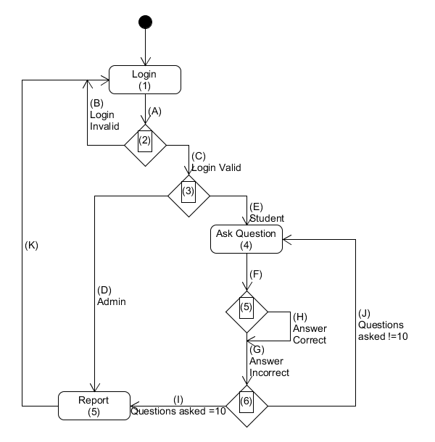

## Paths

Path 1: 1A, 2B

Path 2: 1A, 2C, 3D, 7K

Path 3: 1A, 2C, 3E, 4F, 5G, 6J

Path 4: 1A, 2C, 3E, 4F, 5G, 6I, 7K

Path 5: 1A, 2C, 3E, 4F, 5H, 6J

Path 6: 1A, 2C, 3E, 4F, 5H, 6I, 7K

## Test Cases

Test Case 1: LogIn(wrongname,pass)

Test Case 2: LogIn(admin,admin)

Test Case 3: LogIn(Ciaran,cc) typeAnswer(2)

Test Case 4: Untestable

Test Case 5: LogIn(Ciaran,cc) typeAnswer(1)

Test Case 6: Untestable